Getting Started with the Employee Navigator/RPO integration

* Each Service Bureau will need to create a master username, password, and API key.
  + [guidgenerator.com](https://guidgenerator.com/) is a good resource for the API key:

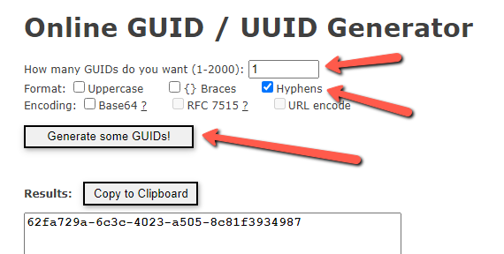

* Every company being setup for Employee Navigator will use the credentials configured here as a means of authenticating.
  + *This takes the place of any database entries to handle cases where partners/re-sellers may have their own master authentication information for their own clients.*
* This authentication information will need to be provided to Employee Navigator during implementation.
  + They in turn will provide a Token that will need to be set on each client as a means of them authenticating with RPO.

RPO - Integration setup steps for you to complete

**PayrollAPI Service**

* Please do the following: In Company 🡪 Master Company Setup 🡪 Status & Services on RPO, add the **PayrollAPI** service and set the Service Level to ‘**EmployeeNavigator**’.

**Onboarding Service**

* Please do the following: In Company 🡪 Master Company Setup 🡪 Status & Services on RPO, add the **Onboarding** service and set the Service Level to ‘**myReadyPay**’.
  + This is absolutely necessary if you wish to maintain bi-directional support of employee demographic data between the two platforms.

**RPO Integration Setup**

* Please do the following: In Company 🡪 Master Company Setup 🡪 Integrations on RPO, click **Add** and enter '**ENav**' in the Name field. Then, select '**EmployeeNavigator**' as the Provider, and ‘**PayrollAPI**’ as the Integration Type from the pull-down menus on the right-hand side of the screen. Click Save, then proceed to the Options sub-tab.

You will first enter your Authentication information - the master username, password, and API key for the service bureau (created in the prerequisite section at the beginning of this article).

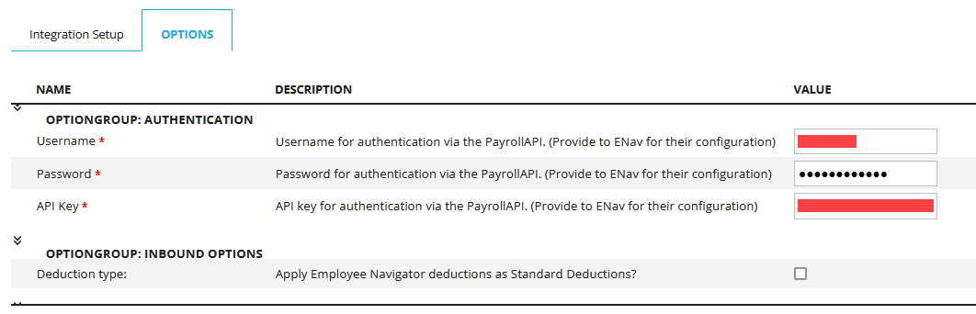

* There is a checkbox that allows you to select what method you will be using. This determines whether you will use the insurance plan method or the older standard deduction method when exchanging benefit data with Employee Navigator.
  + If left unchecked you will use the preferred insurance plan method. If checked it will use the standard deduction method (no insurance plans in use on the company).

* The Outbound Connection section, specifically the Endpoint URL and Outgoing Token are provided by Employee Navigator (as mentioned in the prerequisite section at the beginning of this article).
  + This information will also be the same for all clients using Employee Navigator at your service bureau.

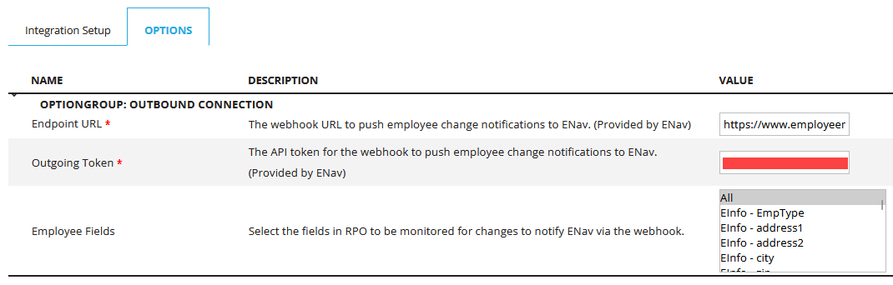

The Employee Fields allow you to control what employee data is tracked for changes and subsequently transferred over to Employee Navigator. Most service bureaus default to All, but you can select multiple objects if you wish to omit anything specific.

**RPO Integration Schedule**

*If the ReadyPay Endpoint 'Get Employee' is set to occur in the previous step, you'll need to add the 'PayrollAPI' Integration Type on the Company | Master Company Setup | Integrations |  Integration Schedules page in RPO.*

* When adding this schedule, select the following…
  + Integration Type: **PayrollAPI**
  + Provider: **EmployeeNavigator**
  + Config: **ENav***(this item comes from the name you used on the integration setup tab)*
  + Action: **EmployeesChangeNotification**
  + Active:It is recommended to leave this unchecked in the beginning, until Employee Navigator has confirmed that their setup is complete.

As a requirement of Employee Navigator, set Run Every (secs) to '**900**' and set the schedule to start at an applicable date and click **Save**. This step should typically occur once Employee Navigator provided the go-ahead in their implementation.

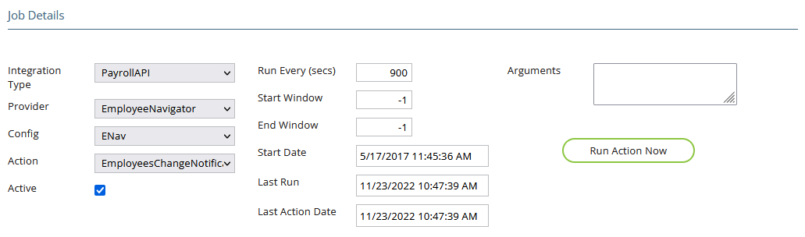

**RPO Integration Code Mapping**

* Please do the following: In Company 🡪 Master Company Setup 🡪 Integrations 🡪 Integration Code Mapping on RPO, select '**EmployeeNavigator**' in the Provider pull-down menu. The Mapping Type pull-down will contain several data elements that will need to be mapped so the two systems can process information successfully:

* Employee Status
* Marital Status
* Pay Frequency

Be sure to choose each Mapping Field option and update the necessary options for each setup type. Click **Save** after each type is completed. Be sure to map as much as you possibly can to avoid issues during employee data transmission.

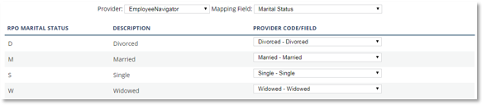

Insurance Setup for you to complete

**Company Insurance Plans**

Each insurance plan built in Employee Navigator should have a corresponding plan added in RPO. On the Company 🡪 Company Setup 🡪 Benefits & Insurance 🡪 Plan Setup page, add the plans and set them up to deduct based on the specifications of the client. Instructions for using the page can be found at [Company Insurance](https://rphelp.freshdesk.com/support/solutions/articles/14000128893-company-setup-insurance). See Considerations below prior to adding plans and Premium information.

**CONSIDERATIONS**: Each Coverage Level (EE Only, EE +Spouse, etc.) and any Age Bands should be configured if RPO will be the system producing ACA forms. When Employee Navigator sends the monthly override premium to RPO, the amount will be reviewed in the Premium table for the Insurance plan being sent to get the appropriate Coverage Level. This is not necessary if Employee Navigator will be the system of record for ACA form creation. In those cases, the monthly override premium can simply come over without the need for creating the full Premium Table.

The Insurance Plan Codes will need to be provided to Employee Navigator during implementation to link the plan setups between the two systems. The page in Employee Navigator, Payroll  | Options, is usually not available via the standard client or service bureau access in that system, but in broker-level screens.

When Insurance Plans are added to employees, the Start Date will be the first premium deduction date and not the Plan Start Date.

No Dependent data comes over from Employee Navigator - keep this in mind when thinking about ACA data requirements.

**Data Validation**

At the instruction of Employee Navigator, employee data reports will need to be generated in Excel so they can validate the Demographic and Insurance setup in RPO. They are available in the Standard Reports library, these reports are:

* **Employee Navigator Deductions** (RP_720_1500) (for clients using the insurance plan method)
* **Employee Navigator Standard Deductions** (RP_720_1502) (for clients using the standard deduction method)
* **Employee Navigator Demographics** (RP_720_1510)

New Employees From Employee Navigator

When a new hire is added in Employee Navigator, it will not contain all the required data needed by RPO to add them properly. This is where the requirement for Onboarding comes in. A notification has been added to the Home | Notifications page to be set up for these transactions. The Pending New Employee notification type should be set up (by any user that is part of new hire processing) and should be set to email when an employee is added.

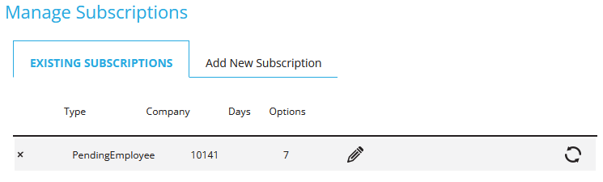

On the Notifications page, click on any Pending Employee in the listing to complete the Add New Employee screen.

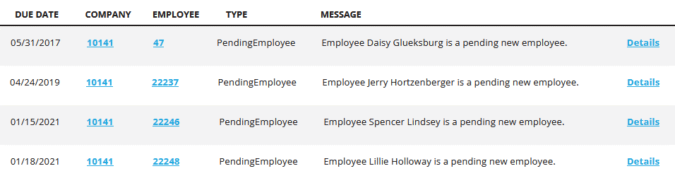

While basic demographic data comes over from Employee Navigator, a lot of details like tax elections do not, making this step required.

Employee Navigator is the system of record for employee benefits

Beginning with version 1.18.1.1, employee insurance or deduction records must be set up and maintained in Employee Navigator. The integration will push new and updated records to ReadyPay Online. Any changes to employee insurance or deduction records made in ReadyPay Online will not flow back to Employee Navigator.

The integration will determine if an insurance or deduction record already exists on an employee and:

* Update the insurance or deduction record if the code is the same. This includes end dating a record.
* Add the insurance or deduction record if the code does not exist on the employee.
* Delete the insurance or deduction record on the employee **ONLY WHEN** it is not contained in the employee's enrollment in Employee Navigator **AND** it has not been used on the employee in RPO (i.e. not in history).